Practical: Network meta-analysis of composite interventions

Oxford 2019

## R packages

We will use the **netmeta** command to run all network meta-analyses.

library(netmeta)

## Connected networks

Load the example dataset:

data(Linde2016)  
  
# Only consider studies including Face-to-face PST (to reduce  
# runtime of example)  
#  
face <- subset(Linde2016, id %in% c(16, 24, 49, 118))

The data comes from a network meta-analysis on the comparative effectiveness of psychological treatments for depressive disorders in primary care. The outcome was response to treatment.

Have a look at the dataset and try to identify the treatments being compared, and the components.

Now let us contact a regular NMA.

net1 <- netmeta(lnOR, selnOR, treat1, treat2, id,  
 data = face, ref = "placebo",  
 sm = "OR", comb.fixed = FALSE)  
summary(net1)

## Number of studies: k = 4  
## Number of treatments: n = 6  
## Number of pairwise comparisons: m = 10  
## Number of designs: d = 4  
##   
## Random effects model  
##   
## Treatment estimate (sm = 'OR', comparison: other treatments vs 'Placebo'):  
## OR 95%-CI  
## Face-to-face PST 1.7967 [0.8618; 3.7459]  
## Face-to-face PST + SSRI 1.9881 [0.5761; 6.8607]  
## Placebo . .  
## SSRI 2.4046 [1.0624; 5.4425]  
## TCA 1.6399 [0.5044; 5.3309]  
## UC 1.7276 [0.4885; 6.1098]  
##   
## Quantifying heterogeneity / inconsistency:  
## tau^2 = 0.1596; I^2 = 52.3%  
##   
## Tests of heterogeneity (within designs) and inconsistency (between designs):  
## Q d.f. p-value  
## Total 4.19 2 0.1229  
## Within designs 0.00 0 --  
## Between designs 4.19 2 0.1229

forest(net1, xlim = c(0.2, 50))

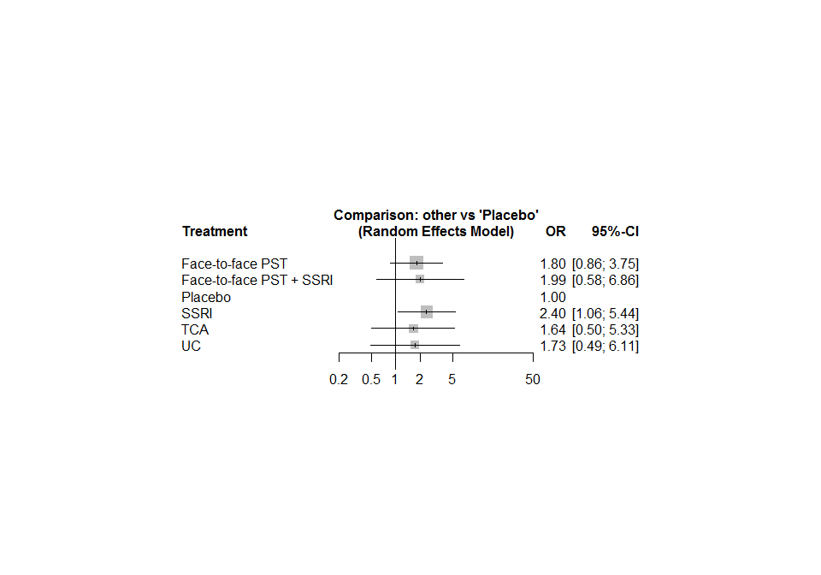

Does the additivity assumption seems plausible in this example?

Let us perform a component NMA.

nc1 <- netcomb(net1, inactive = "placebo")  
summary(nc1)

## Number of studies: k = 4  
## Number of treatments: n = 6  
## Number of active components: c = 4  
## Number of pairwise comparisons: m = 10  
##   
## Results for combinations (additive model, random effects model):  
## OR 95%-CI z p  
## Face-to-face PST 1.4474 [0.7703; 2.7195] 1.15 0.2505  
## Face-to-face PST + SSRI 2.6466 [0.8692; 8.0584] 1.71 0.0867  
## Placebo 1.0000 [1.0000; 1.0000] -- --  
## SSRI 1.8285 [0.9386; 3.5623] 1.77 0.0761  
## TCA 1.4657 [0.4676; 4.5940] 0.66 0.5119  
## UC 1.3917 [0.4279; 4.5261] 0.55 0.5828  
##   
## Results for components (random effects model):  
## OR 95%-CI z p  
## Face-to-face PST 1.4474 [0.7703; 2.7195] 1.15 0.2505  
## SSRI 1.8285 [0.9386; 3.5623] 1.77 0.0761  
## TCA 1.4657 [0.4676; 4.5940] 0.66 0.5119  
## UC 1.3917 [0.4279; 4.5261] 0.55 0.5828  
##   
## Quantifying heterogeneity / inconsistency:  
## tau^2 = 0.1433; I^2 = 49.9%  
##   
## Heterogeneity statistics:  
## Q df.Q pval  
## Additive model 5.99 3 0.1121  
## Standard model 4.19 2 0.1229  
## Difference 1.80 1 0.1802

forest(nc1, xlim = c(0.2, 50))

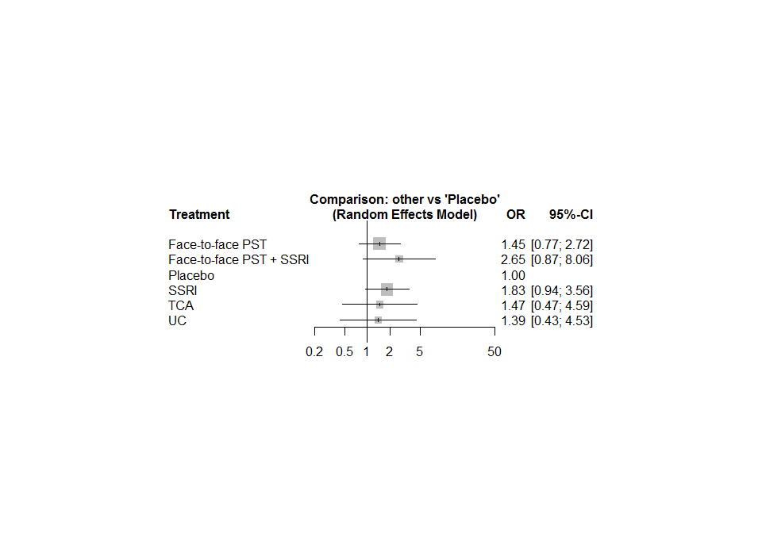

What do you observe?

## Disconnected networks - optional exercise

For this exercise we will use an artificial dataset.

# Artificial dataset  
#  
t1 <- c("A + B", "A + C", "A" , "A" , "D", "D", "E")  
t2 <- c("C" , "B" , "B + C", "A + D", "E", "F", "F")  
#  
mean <- c(4.1, 2.05, 0, 0, 0.1, 0.1, 0.05)  
se.mean <- rep(0.1, 7)  
#  
study <- paste("study", c(1:4, 5, 5, 5))  
#  
dat <- data.frame(mean, se.mean, t1, t2, study,  
 stringsAsFactors = FALSE)  
  
trts <- c("A", "A + B", "A + C", "A + D",  
 "B", "B + C", "C", "D", "E", "F")

Use the netconnection function to check whether the network is connected

netconnection(t1, t2, study)

## Number of studies: k = 5  
## Number of treatments: n = 10  
## Number of pairwise comparisons: m = 7  
## Number of networks: 4  
##   
## Distance matrix:  
## F D E B + C A A + D A + B C A + C B  
## F 0 1 1 . . . . . . .  
## D 1 0 1 . . . . . . .  
## E 1 1 0 . . . . . . .  
## B + C . . . 0 1 2 . . . .  
## A . . . 1 0 1 . . . .  
## A + D . . . 2 1 0 . . . .  
## A + B . . . . . . 0 1 . .  
## C . . . . . . 1 0 . .  
## A + C . . . . . . . . 0 1  
## B . . . . . . . . 1 0

How many disconnected networks are there?

Now let’s fit the component NMA model and look at results.

dc1 <- discomb(mean, se.mean, t1, t2, study, seq = trts)  
dc1

## Additive model (fixed effects model):  
## treat1 treat2 95%-CI z p  
## study 1 A + B C 4.1000 [ 3.9040; 4.2960] 41.00 0  
## study 2 A + C B 2.0500 [ 1.8540; 2.2460] 20.50 < 0.0001  
## study 3 A B + C 0.0000 [-0.1960; 0.1960] 0.00 1.0000  
## study 4 A A + D 0.0000 [-0.1960; 0.1960] 0.00 1.0000  
## study 5 D E 0.0833 [-0.1127; 0.2793] 0.83 0.4047  
## study 5 D F 0.1167 [-0.0793; 0.3127] 1.17 0.2433  
## study 5 E F 0.0333 [-0.1627; 0.2293] 0.33 0.7389  
##   
## Additive model (random effects model):  
## treat1 treat2 95%-CI z p  
## study 1 A + B C 4.1000 [ 3.9040; 4.2960] 41.00 0  
## study 2 A + C B 2.0500 [ 1.8540; 2.2460] 20.50 < 0.0001  
## study 3 A B + C 0.0000 [-0.1960; 0.1960] 0.00 1.0000  
## study 4 A A + D 0.0000 [-0.1960; 0.1960] 0.00 1.0000  
## study 5 D E 0.0833 [-0.1127; 0.2793] 0.83 0.4047  
## study 5 D F 0.1167 [-0.0793; 0.3127] 1.17 0.2433  
## study 5 E F 0.0333 [-0.1627; 0.2293] 0.33 0.7389  
##   
## Number of studies: k = 5  
## Number of treatments: n = 10  
## Number of active components: c = 6  
## Number of pairwise comparisons: m = 7  
##   
## Results for combinations (additive model, fixed effects model):  
## 95%-CI z p  
## A 3.0750 [ 2.9364; 3.2136] 43.49 0  
## A + B 5.1250 [ 4.8850; 5.3650] 41.85 0  
## A + C 4.1000 [ 3.8600; 4.3400] 33.48 < 0.0001  
## A + D 3.0750 [ 2.8350; 3.3150] 25.11 < 0.0001  
## B 2.0500 [ 1.9114; 2.1886] 28.99 < 0.0001  
## B + C 3.0750 [ 2.8350; 3.3150] 25.11 < 0.0001  
## C 1.0250 [ 0.8864; 1.1636] 14.50 < 0.0001  
## D -0.0000 [-0.1960; 0.1960] -0.00 1.0000  
## E -0.0833 [-0.3605; 0.1938] -0.59 0.5557  
## F -0.1167 [-0.3938; 0.1605] -0.82 0.4094  
##   
## Results for combinations (additive model, random effects model):  
## 95%-CI z p  
## A 3.0750 [ 2.9364; 3.2136] 43.49 0  
## A + B 5.1250 [ 4.8850; 5.3650] 41.85 0  
## A + C 4.1000 [ 3.8600; 4.3400] 33.48 < 0.0001  
## A + D 3.0750 [ 2.8350; 3.3150] 25.11 < 0.0001  
## B 2.0500 [ 1.9114; 2.1886] 28.99 < 0.0001  
## B + C 3.0750 [ 2.8350; 3.3150] 25.11 < 0.0001  
## C 1.0250 [ 0.8864; 1.1636] 14.50 < 0.0001  
## D -0.0000 [-0.1960; 0.1960] -0.00 1.0000  
## E -0.0833 [-0.3605; 0.1938] -0.59 0.5557  
## F -0.1167 [-0.3938; 0.1605] -0.82 0.4094  
##   
## Results for components (fixed effects model):  
## 95%-CI z p  
## A 3.0750 [ 2.9364; 3.2136] 43.49 0  
## B 2.0500 [ 1.9114; 2.1886] 28.99 < 0.0001  
## C 1.0250 [ 0.8864; 1.1636] 14.50 < 0.0001  
## D -0.0000 [-0.1960; 0.1960] -0.00 1.0000  
## E -0.0833 [-0.3605; 0.1938] -0.59 0.5557  
## F -0.1167 [-0.3938; 0.1605] -0.82 0.4094  
##   
## Results for components (random effects model):  
## 95%-CI z p  
## A 3.0750 [ 2.9364; 3.2136] 43.49 0  
## B 2.0500 [ 1.9114; 2.1886] 28.99 < 0.0001  
## C 1.0250 [ 0.8864; 1.1636] 14.50 < 0.0001  
## D -0.0000 [-0.1960; 0.1960] -0.00 1.0000  
## E -0.0833 [-0.3605; 0.1938] -0.59 0.5557  
## F -0.1167 [-0.3938; 0.1605] -0.82 0.4094  
##   
## Quantifying heterogeneity / inconsistency:  
## tau^2 = NA  
##   
## Heterogeneity statistics:  
## Q df.Q pval  
## Additive model 0.06 0 --  
## Standard model -- -- --  
## Difference -- -- --

forest(dc1, ref = "F")

